**Weeks 11-12**

**Idea:**

At the first meeting we got to know our group and we started by brainstorming ideas of what we should do for this project. We got a few different ideas and we decided to choose an automatic pet lizard feeder for our initial idea. We drew raw sketches of the feeder and started to think about how it would work. Also we made a discord channel for communication through the project.

After the first meeting there came some new ideas on discord and we decided to change our pet feeder idea for the 360 degree sonar system.

**Process:**

So in the first week we registered our group to the moodle, chose the topic for the project and made a folder to Google Drive for our project.

Next step was to organize what to do:

* Decide the design for the box of our sonar system
* Make circuit design and arduino coding with tinkercad and simulate it
* Think how to send data to phone via bluetooth and how to visualize it
* Assemble the parts for the final result

We got several nice ideas for the result of our project and we ended up choosing a pyramid-shaped box for our sonar system. There are few pictures of the sketches by Aleksanteri and Konsta and the first 3D-model by Aleksi below. Konsta also had some components used in our job so he sent a picture where we could see the proportions of those.

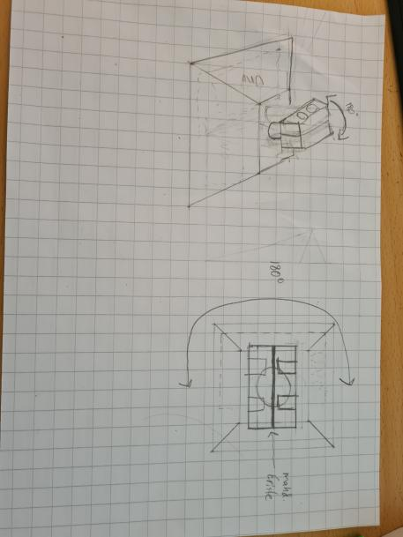

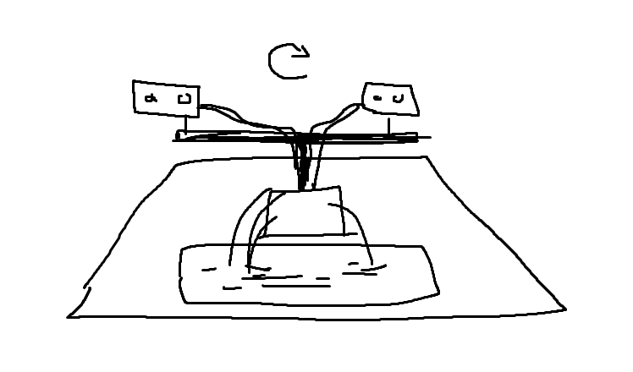

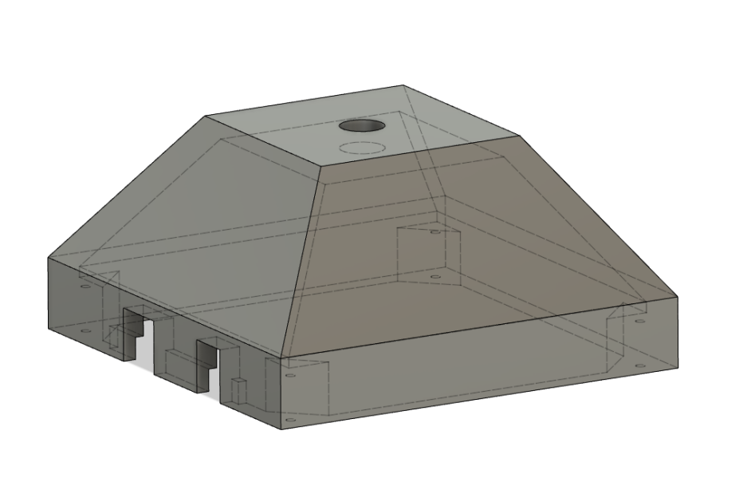

We needed a few extra components for our job in addition to the default ones which were two ultrasonic sensors and the bluetooth module so we ordered those from supervisors. Konsta wrote the introductory report to the blog site of the course.

Project team: Aleksanteri, Aleksi, Konsta and Kaarlo